How to Use Client Relevance Studio
Getting Started 2
The Interface at a Glance 2
Evaluating Relevance (Batch & Single) 3
Using the Built-In Library 4
Saving Custom Bookmarks 5
Navigating Your History 6
Searching and Filtering Results 7
Exporting Your Data 8
Quick Pro-Tips 8

Welcome to Client Relevance Studio, a modern, standalone IDE for writing, testing, and managing HCL BigFix relevance. This guide will walk you through the core features and how to get the most out of your relevance testing.

Getting Started
To ensure the underlying BigFix engine can access deep system metrics (like local users, secure registry keys, or Windows defender statuses), you should run the application with elevated privileges.
- Extract the downloaded .zip file to a local folder.
- Right-click Advanced_QNA.exe and select "Run as administrator".
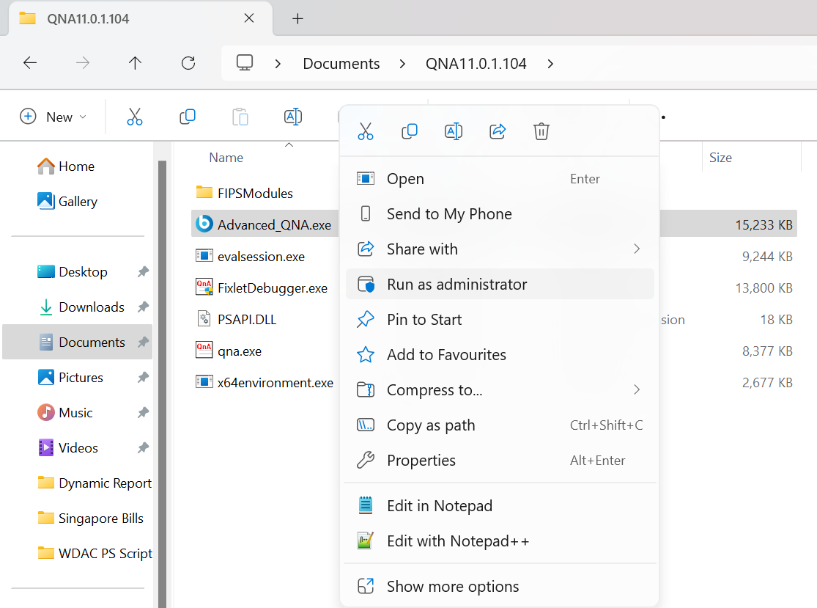

The Interface at a Glance
The studio is divided into three highly customizable panes. You can drag the borders (horizontal and vertical dividers) between the panes to resize them to your liking:
- The Left Sidebar: Your repository. It contains the built-in Relevance Library, your My Bookmarks, and your Recent History.
- Expression Editor (Top Right): A syntax-aware CodeMirror text area where you write and modify your relevance queries. Features line numbers and bracket matching.
- Evaluation Results (Bottom Right): Displays the parsed answers, execution time (in milliseconds), and any errors returned by the QnA engine.
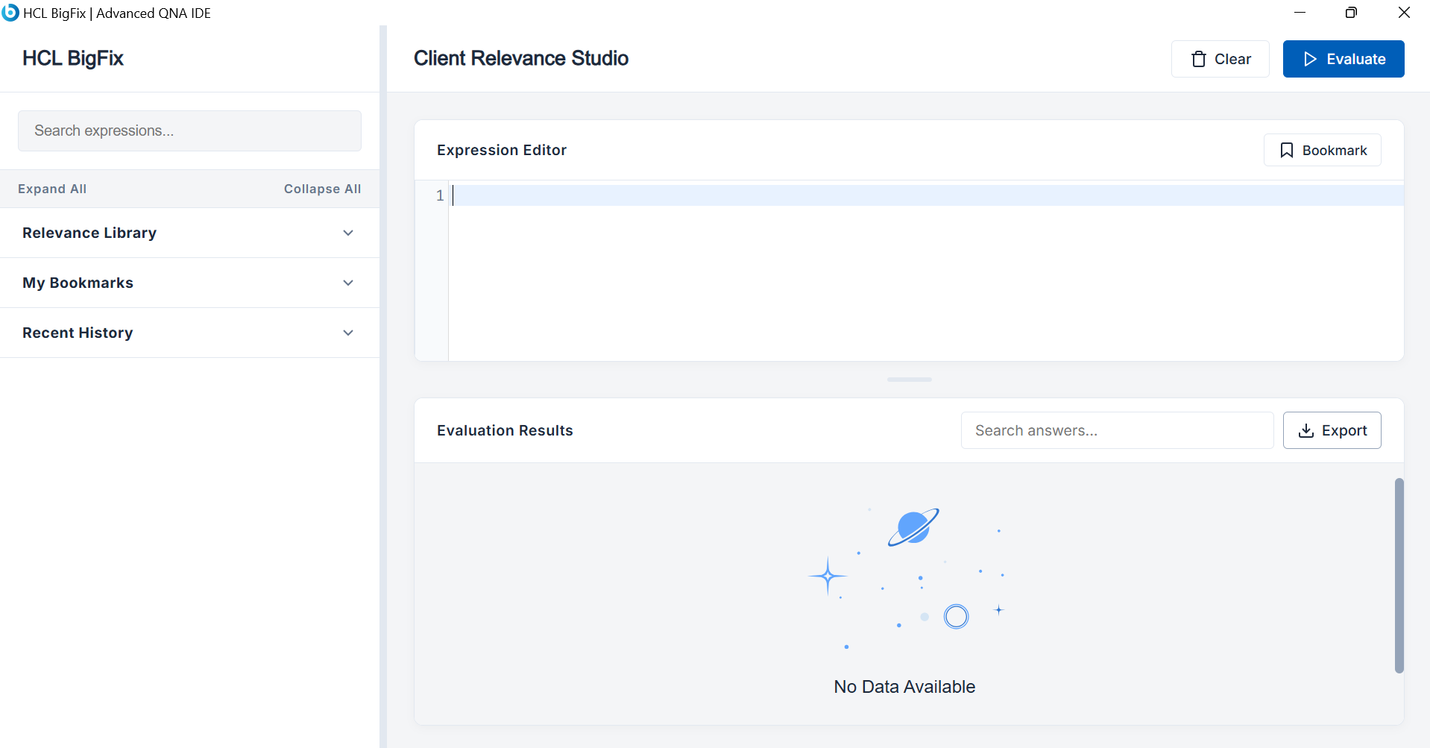

Evaluating Relevance (Batch & Single)
- Type your relevance query into the Expression Editor (e.g., names of drives).
- Click the blue Evaluate button in the top right, or use the keyboard shortcut Ctrl + Enter.
- The results will appear in the pane below, showing a green SUCCESS or red ERROR status, along with the total execution time.
Batch Evaluation: You don't have to evaluate one query at a time. If you write multiple relevance statements on separate lines, the Studio will evaluate all of them simultaneously and stack the result blocks in the bottom pane.
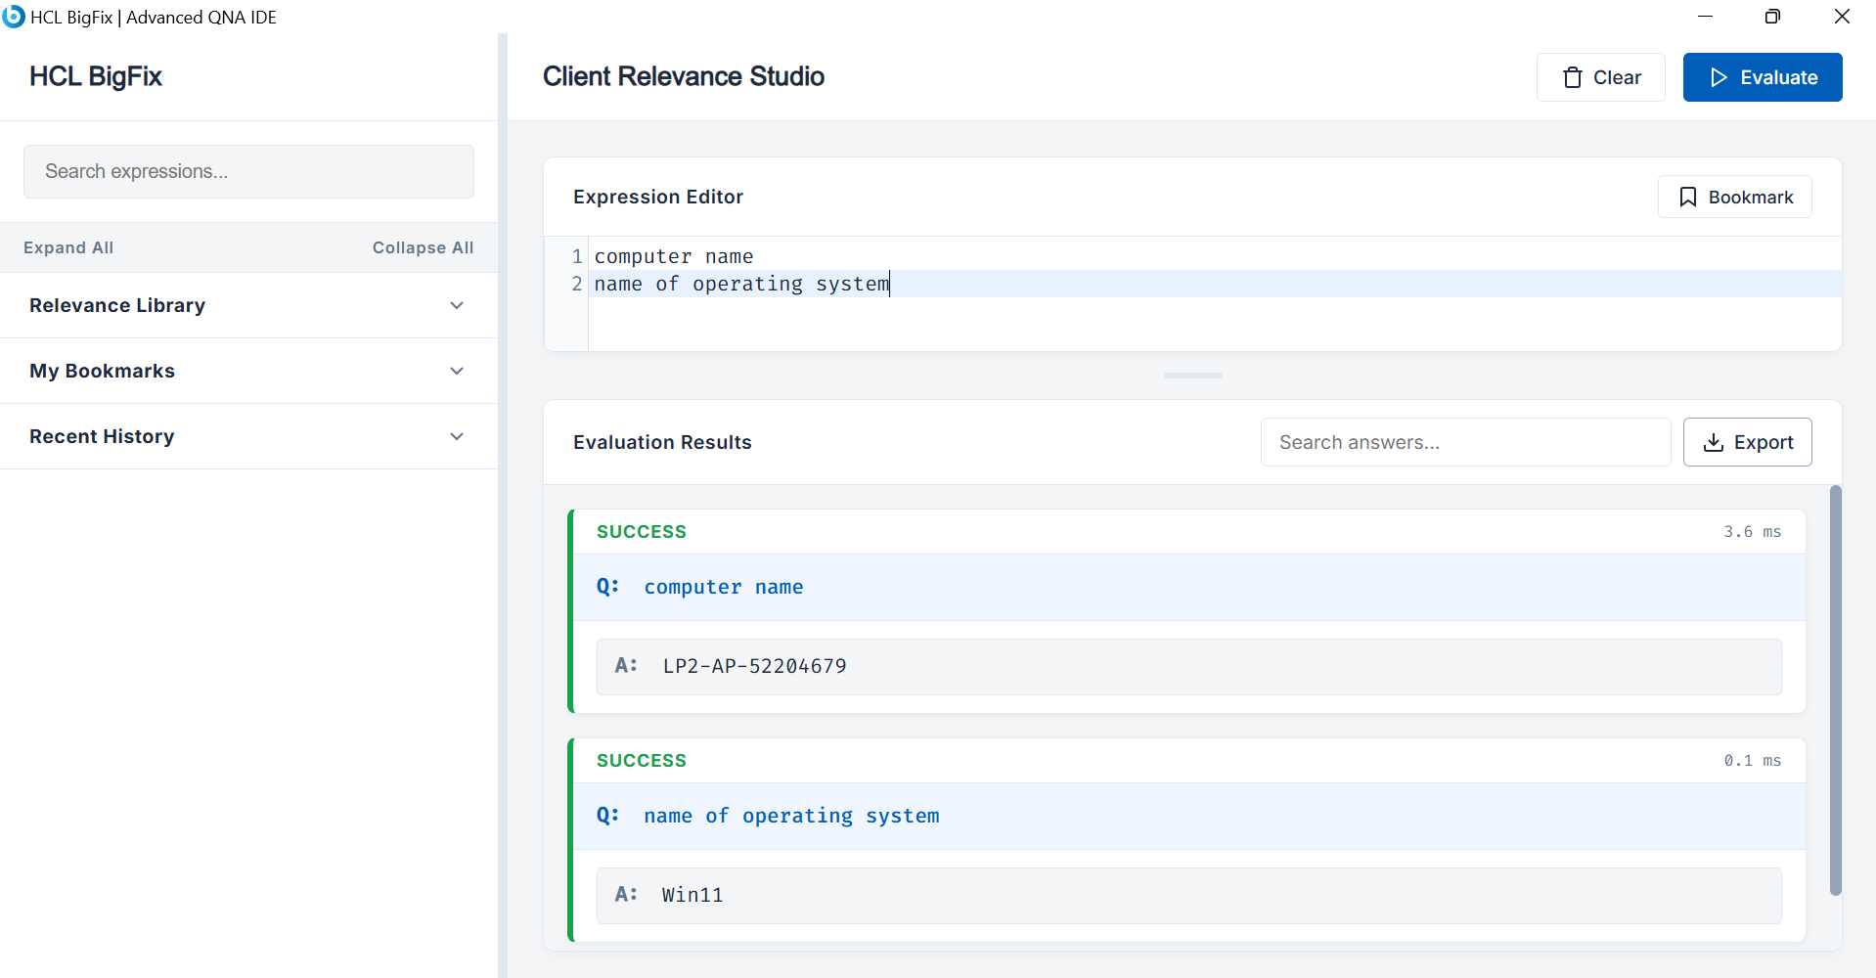

Using the Built-In Library
Don't want to memorize basic properties? The sidebar contains a categorized library of standard queries.
- Click Expand All or Collapse All at the top of the sidebar to easily navigate the categories (Operating System, Hardware, Network, etc.).
- Click on any item card (e.g., OS Version #2) to instantly load that relevance snippet into your editor.
- Use the "Search expressions..." bar at the top of the sidebar to instantly filter the library, your bookmarks, and your history for specific keywords.
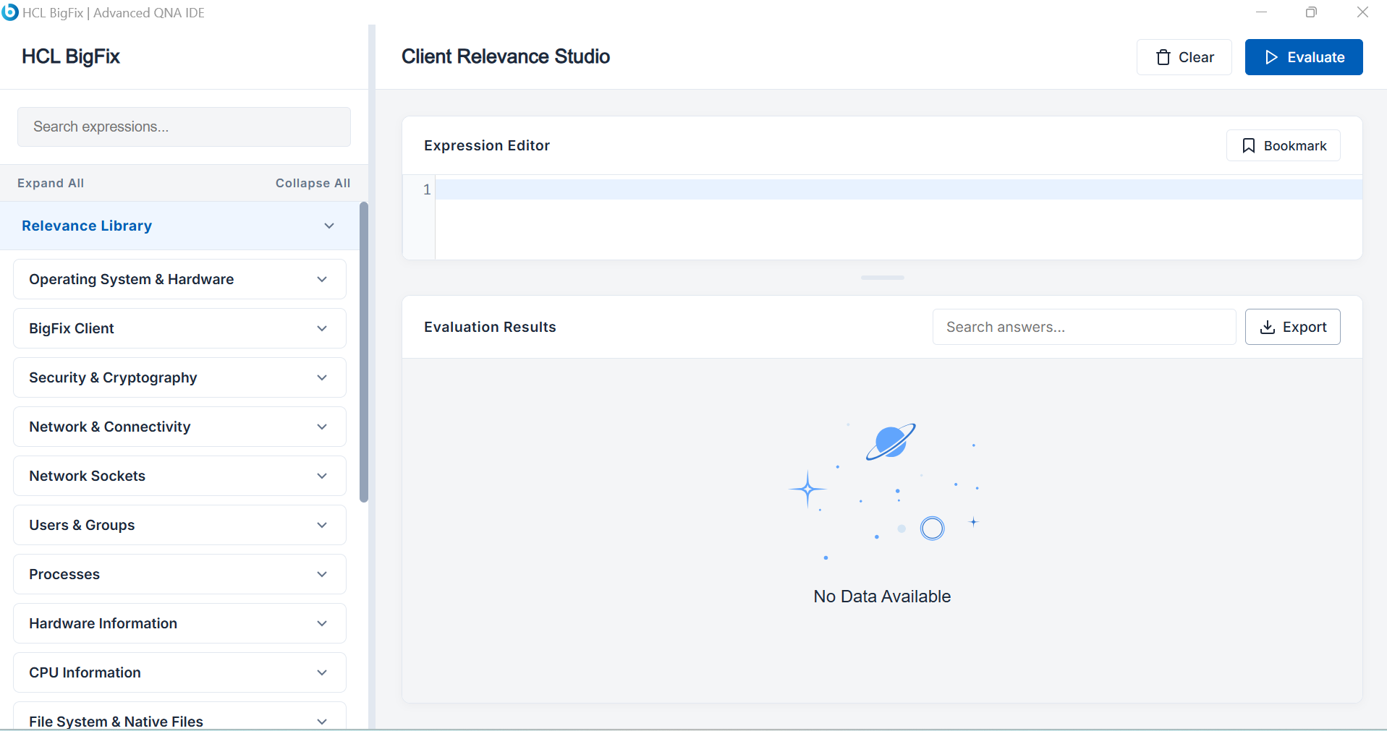
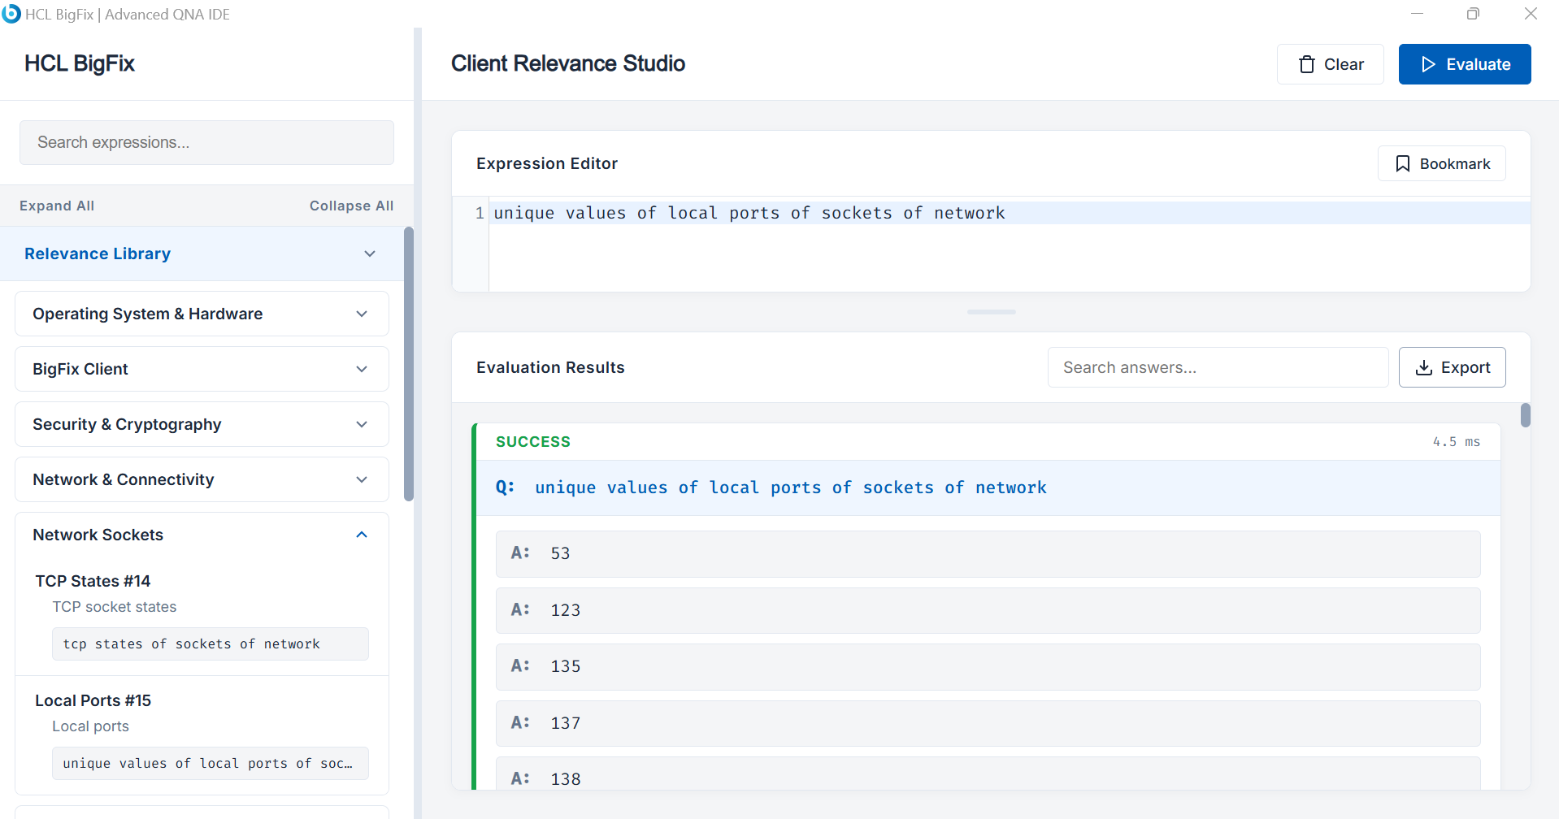

Saving Custom Bookmarks
If you have a complex query that you use frequently, you can save it directly in the app.
- Type or paste your code into the Expression Editor.
- Click the Bookmark button located in the header of the Expression Editor pane.
- A prompt will ask for a short Title and an optional Description.
- Your snippet is now saved under the My Bookmarks accordion in the sidebar for easy access across reboots.
- To delete a bookmark: Hover over the item in the sidebar and click the Trash Can icon that appears on the right.
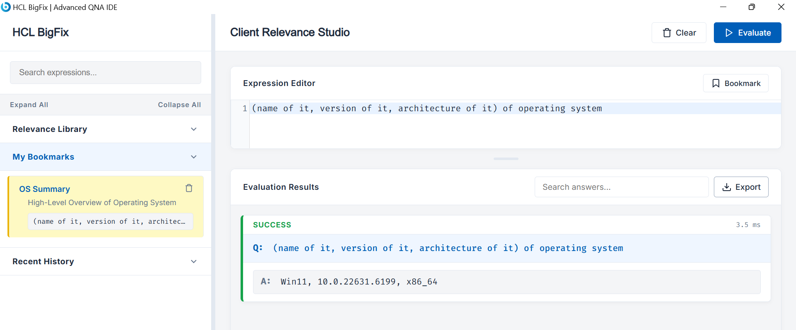

Navigating Your History
Accidentally cleared your editor? No problem.
Every time you hit "Evaluate", the studio silently saves your query to the Recent History tab in the sidebar.
- It automatically stores your last 100 queries.
- Queries older than 10 days are automatically purged.
- Click any history item to instantly load it back into the editor.
- Click the Clear History button inside the tab to wipe your local log.
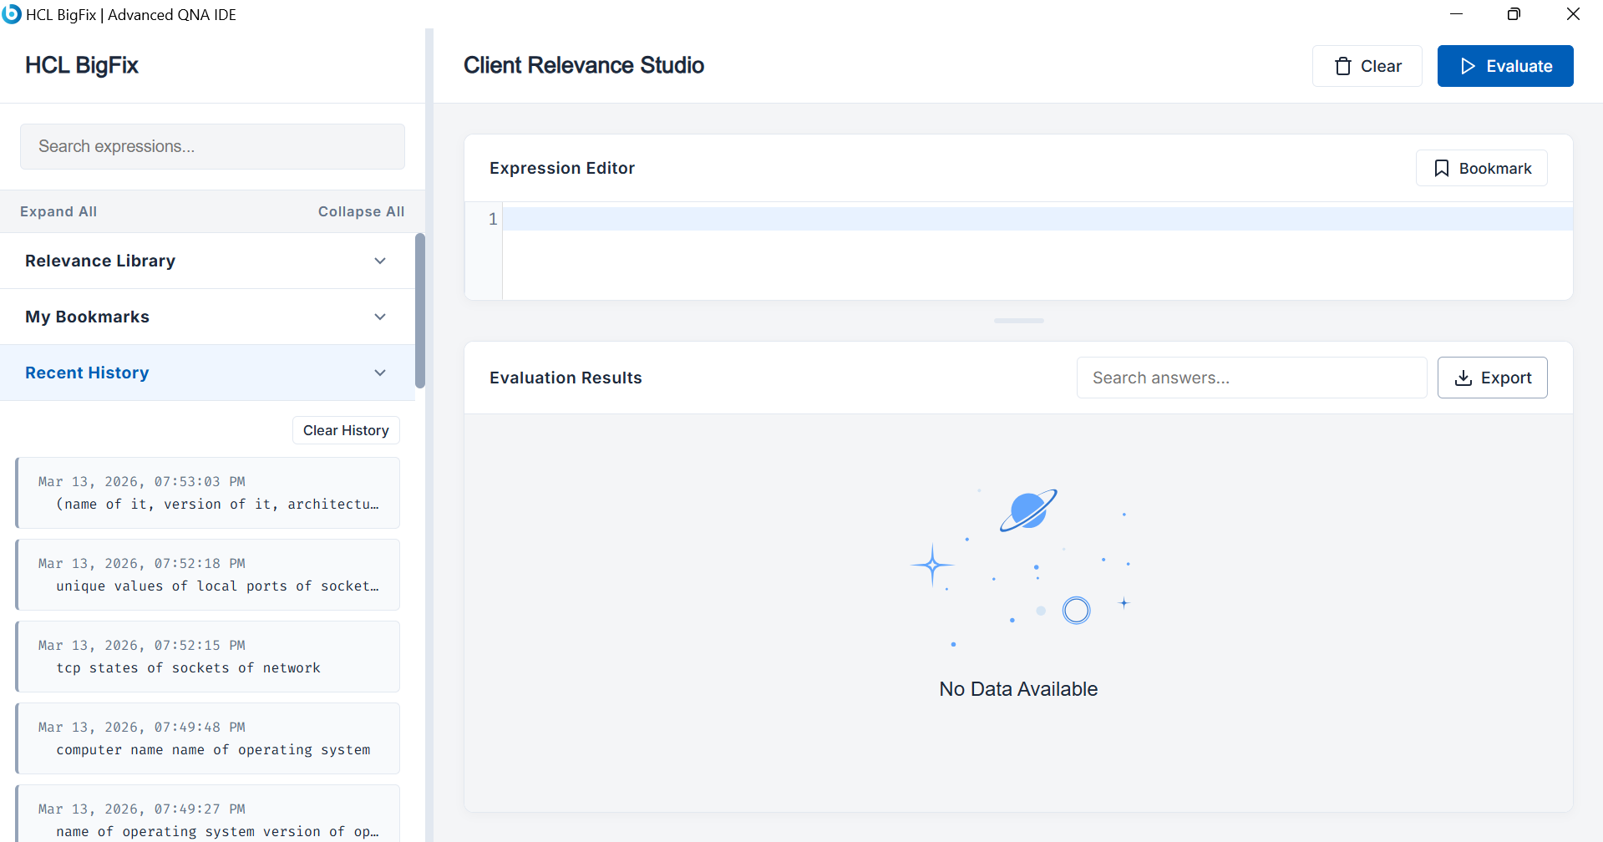

Searching and Filtering Results
If your query returns hundreds of answers (like names of services or names of files of folder "C:\"), finding a specific item can be tedious.
- Use the "Search answers..." input box in the Evaluation Results header.
- Typing here will dynamically filter the result blocks in real-time, displaying only the rows that match your search and highlighting the matched text in yellow.
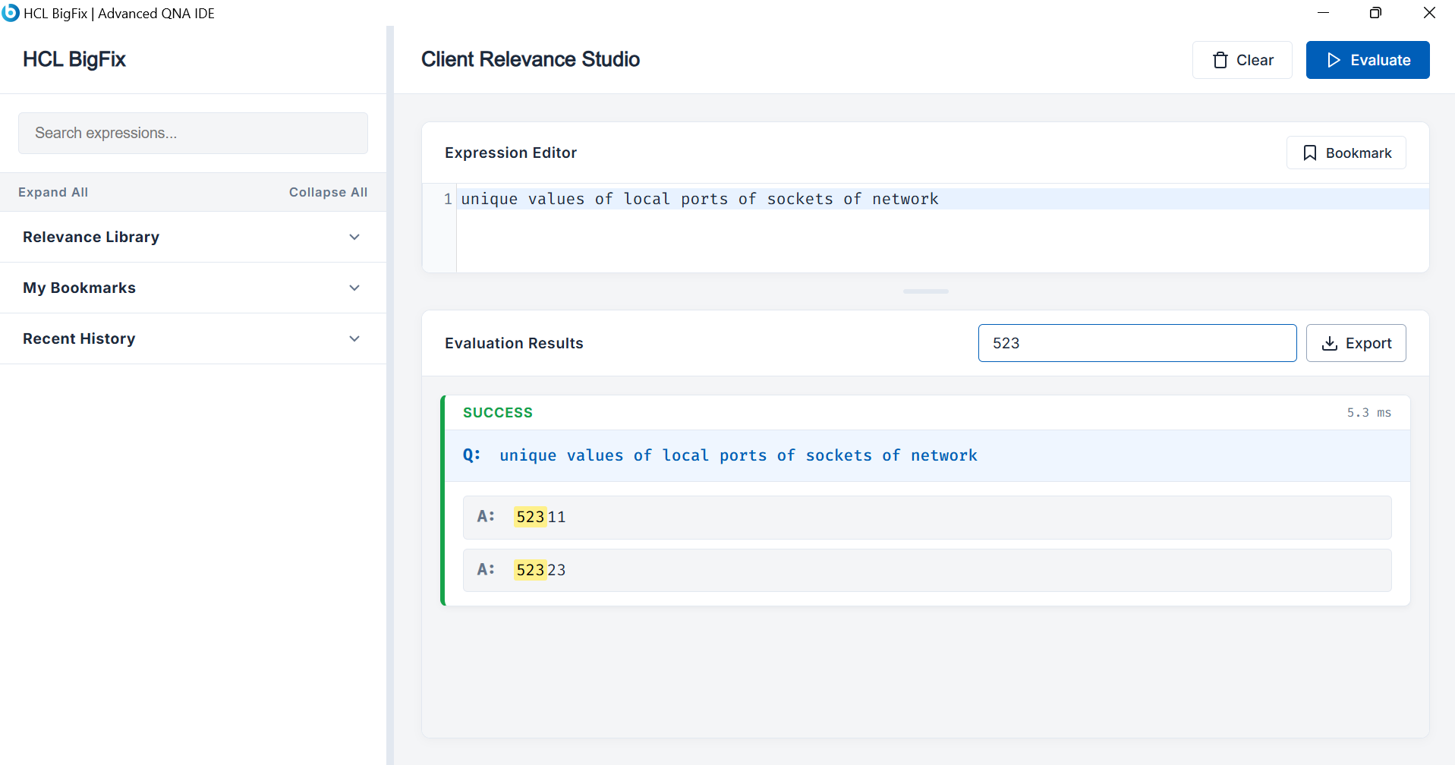

Exporting Your Data
Need to share your findings with a colleague or attach them to a ticket?
- Click the Export button in the Evaluation Results header.
- Select your desired format: CSV, PDF, HTML, TXT, JSON, or XML.
- Choose your scope:
  - Search Results: If you have typed something into the "Search answers..." filter, this option will only export the lines that currently match your search.
  - All Results: Exports everything currently rendered in the bottom pane, ignoring the search filter.
- A save dialog will prompt you to save the file to your local machine.
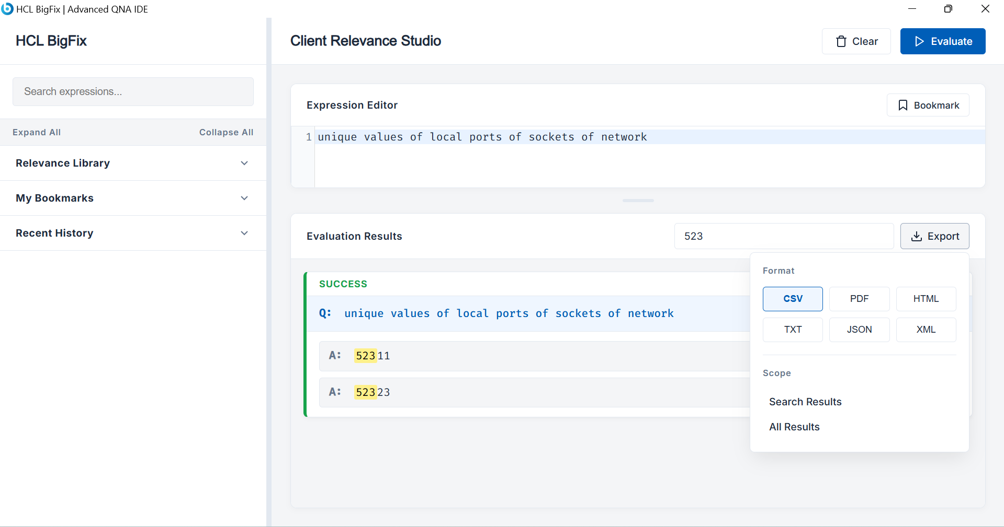

Quick Pro-Tips
- Fast Copying: Click on any individual Question row (Q:) or Answer row (A:) in the Results pane, and it will automatically copy that specific text to your clipboard. The row will flash blue to confirm!
- Persistence: All your bookmarks, history, and even the current un-evaluated text sitting in your editor are saved to your local machine cache. If you close the app, everything will be exactly where you left it when you reopen it.
- Clear Editor: Click the Clear button next to Evaluate to quickly wipe the editor pane and clear the results board to start fresh.

